JABATAN PERKHIDMATAN AWAM
JABATAN PERDANA MENTERI
NEGARA BRUNEI DARUSSALAM

QUOTATION DOCUMENT
Quotation Reference | : | JPA/1.4/SH2021/028
Quotation Title | : | 1 YEAR CONTRACT FOR FOOD AND BEVERAGE KIOSK OPERATION AT PUBLIC SERVICE DEPARTMENT SIMPANG 156, JALAN KUMBANG PASANG
Date of Quotation Submission | : | 8 FEBRUARY 2022 / 2.00 PM
Quotation Fee | : | BND$5.00

INSTRUCTION TO TENDERERS

This quotation is open to Vendor with a Company Registration Certificate (FORM 16/17or Form X). The Vendor shall furnish valid registration documents.

Tenderers MUST submit with their Company Registration Certificate (Form 16/17 or Form X) and shall be updated and valid as an attachment to the tender document.

Non-compliance with the conditions in any respect shall render the tender liable to rejection.

Site Location

The location of site is at the corridor of the side entrance within the protected area of Public Service Department Building, Jalan Kumbang Pasang.

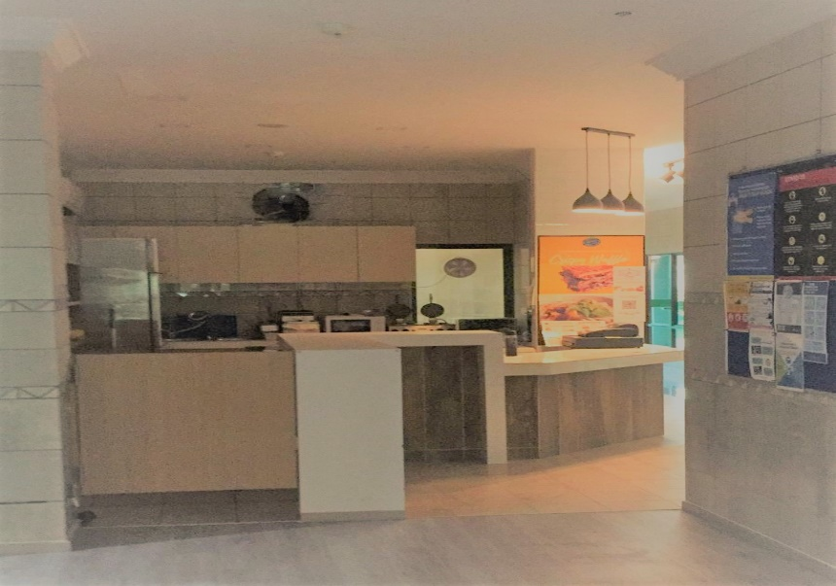

Tenderer is advised to seek assistance from the Contact Person as indicated below.

Contact Person | Contact Number
Merdina binti Md Salleh | +673 8615723
Siti Susianty Binti Hj Metussin | +673 8809884

Rental Proposal

Vendor must propose a fixed monthly rent based on current market values inclusive of water and electricity bills.

Vendor must give a two (2) month notice prior withdrawing from any agreement with Public Service Department. Failure to do so will incur penalty charges covering the maintenance and utility charges for 2 months.

Validity

Quotations shall remain valid for six (6) calendar months from the closing date of quotation and no tenderers may withdraw his quotation within that period.

Submission and Lodging of Quotation

The quotation is to be lodged not later than 2.00pm, on Tuesday, 8th February 2022, at the Quotation Box located at the Ground Floor Lobby, Bangunan Jabatan Perkhidmatan Awam, Jalan Kumbang Pasang.

Tenderers are to fill in and submit the Quotation document provided, including all relevant attachments, in their quotation submission. The quotation shall be properly sealed in envelope, and must be clearly marked and addressed as follows:

PENGERUSI
JAWATANKUASA SEBUTHARGA JABATAN PERKHIDMATAN AWAM
JABATAN PERKHIDMATAN AWAM
NEGARA BRUNEI DARUSSALAM
Quotation for:
1 YEAR CONTRACT FOR FOOD AND BEVERAGE KIOSK OPERATION AT PUBLIC SERVICE DEPARTMENT SIMPANG 156, JALAN KUMBANG PASANG
Quotation ref: JPA/1.4/SH2021/028

JABATAN PERKHIDMATAN AWAM
JABATAN PERDANA MENTERI
NEGARA BRUNEI DARUSSALAM

FORM OF QUOTATION

QUOTATION FOR | : | 1 YEAR CONTRACT FOR FOOD AND BEVERAGE KIOSK OPERATION AT PUBLIC SERVICE DEPARTMENT SIMPANG 156, JALAN KUMBANG PASANG
QUOTATION NO | : | JPA/1.4/SH2021/028
CLOSING DATE | : | 8 FEBRUARY 2022 (2.00 PM)

- I/We the undersigned having read and fully understood the instruction and specification regarding the above and agree to meet instructions and specification as well willing to make payment of the fixed monthly rent for a sum of:

Brunei Dollars : _________________________________________________

- I/We have seen the documents and specification and deemed to have a clear understanding.

3. I/We confirm that the Quotation has been calculated on a firm price basis and is inclusive of all necessary allowances to adequately cover price escalation of labour, products and all other relevant items.

4. I/We agree that this Quotation remains open for consideration and acceptance for Six (6) Calendar Months from the last date for submission of same.

Name of Company | :
Name of Authorised Person | :
Signatory of Authorised | :
Company Stamp | :

DETAIL OF COMPANY

1. | Name of Company | :
2. | Stamp of Company
3. | Name of Authorised Person | :
4. | No of Identity card and colour | :
5. | Position of Authorised Person | :
6. | Signatory of Authorised Person | :
7. | Address of Company | :
8. | Telephone | : | (O)
 |  |  | (M)
 |  |  | (F)
9. | Email address | :

GENERAL CONDITIONS

Scope of Work

- The Kiosk will be able to cater for staff and clients of Public Service Department (PSD) as well visitors from surrounding buildings through providing light meals, snacks and refreshments throughout the proposed opening hours.

- All food (hot or cold) must be pre-cooked. However, all beverages (hot or cold) may be prepared at kiosk.

- Vendor shall supply all necessary crockery, glassware and cutlery for the operation of the Kiosk.

- Vendor is encouraged to use food warmer and to be set up at the kiosk.

- No live cooking is allowed in Public Service Department Building.

- Food and beverages may be served for both dine-in and take-outs.

- Vendor shall at all times maintain high standards of hygiene and general cleanliness in the preparation, handling and serving of food and beverages and in the use and maintenance of fittings, utensils and equipment and ensure compliance with all relevant national legislation, Codes of Practice and Guidelines.

- Vendor shall provide number of properly trained staff and take all reasonable precautions to ensure that all staff shall be suitably dressed and shall be clean and presentable.

- Vendor is to be responsible for the replacement of any items of equipment or furniture (e.g. tables and chairs) provided by PSD which may be damaged or destroyed through negligence of the vendor or its employees.

- Maintenance and replacement of equipment and of interior or preparation area and services is the responsibility of the vendor with the exception of equipment owned by PSD. PSD will not be responsible for the cleaning, repair and ongoing-maintenance of the vendor’s appliances/equipment.

- Vendor shall comply with all reasonable directions of PSD in connection with the good management of the Kiosk.

Proposed Opening Hours

Monday – Thursday 7:30am – 1:30pm* or 7:30am – 4:00pm*
Saturday 7:30am – 1.30pm* or 7:30am – 4:00pm*

*subject to changes in operation hours of PSD.

Cost of Food and Drinks

Should be made affordable and same price as other branches (if any)

Kiosk Attendant

Vendor must be able to provide an attendant/s at the Kiosk at all times

Small Appliances

Vendor must have appliances such as coffee maker, coffee machines, microwave etc.

Health and Safety

The Vendors shall at all times observe adequate safety precautions on Site to ensure the safety of the occupier of the premise, public as well as of the Vendors’ own employees. In this respect he shall comply to all legislations and standards pertaining to his work.

The Vendors shall be solely responsible for all loss, costs and expenses in respect to any injury persons incurred in the performance of the services or caused in any other manner whatsoever by the Vendors, Sub-Vendors or the Vendors own employees.

The Vendors shall ensure that the workers have the relevant safety insurance in place.

The Vendors’ attention is specifically drawn to the following order and its relevant regulations and Safety Manual, copies of which shall at all times be kept on the Sites:

  - Workplace Safety and Health Order, 2009 and its Regulations
  - Any other relevant legislations and standards

The Vendors shall provide a properly equipped first-aid box, which shall be accessible at all times.

Cleanliness

Vendor must keep clean at all times areas designated for the use of the services, during the operation, including preparation area and server area including all equipment, utensils, tables, chairs and floors.

Throughout the progress of the works, Vendor shall maintain the site in a neat condition. Any spillage on the compound shall be cleaned immediately.

The Vendor shall at suitable intervals remove any accumulation of rubbish or refuse materials. Suitable waste bins must be provided by the vendor and make such satisfactory arrangements as are necessary for the removal and disposal of waste. At no time shall any person employed by the Vendors discard any litter or garbage on or any other site of the premise except into a suitable waste receptacle.

Vendor must not discharge any harmful or unpleasant substances including waste oil into the drains and pipes.

The Vendors shall ensure that equipment on site are kept safely. No claims for the loss of equipment etc., will be entertained.

Renovations

Should Vendor request to renovate the said area, the renovation shall be subject to the approval of Public Service Department and fully at vendor own expense.

Duration of Implementation/Readiness

The commencement date/start date is not more than a month after the agreement is signed.

Making Good Any Damages

Any existing work damaged shall be made good at Vendors’ own expense with materials and workmanship to match in every respect the surrounding work and shall be properly bonded therefore.

Alternatively, the Client may repair the damage and the Vendors shall pay to the Client the cost of repairing the loss or damage forthwith upon demand from the Client.

Otherwise, where in the opinion of the Client, it is not practical or desirable to repair the loss or damage, the Client may estimate the cost of the loss or damage and deduct such estimated amount from the amount owing to the Vendors hereunder.

Site Restrictions

The Vendors shall comply with all the regulations that might be imposed by the authorities concerned with regards to movements inside the compounds. The Vendors shall be solely responsible to seeing that his employees follow these regulations.

Cancellation

The Client reserve the right to cancel the contract at any time in the event of breach to the term of the Quotation Document and Contract Agreement.

Withdrawal

Withdrawal after awarded may result in vendor to be blacklisted for a period of time.

INFORMATION TO BE PROVIDED

ITEM | DESCRIPTION | REMARK
1 | Rental proposal  A fixed monthly rent based on current market values inclusive of water and electricity bills.
2 | Food and Beverage Kiosk Menu  - A range of quality hot and cold food and beverages  - A range of hot and cold snacks  - At least one healthy food option (salad/keto/low carb/whole food etc.) and at least one healthy beverage option (fruit smoothies/fresh fruit juice etc.)  - [Optional] Catering to small to medium sized events within the PSD building (inclusive of cutlery, table cloth, chair cover etc.).  menu including price lists.
3 | Company Experience  Vendor to provide information on similar experience (if any)

Name of Company | :
Name of Authorised Person | :
Contact No. | :
Signatory of Authorised | :
Company Stamp | :

